1.    Include “Cert Type” in the Report Criteria:

•         Currently, we are unable to search by Cert Type and the data retrieved is for all Forms included in the shipment booking even if it is not required for that particular country. As a result, information collected is messy and a lot of sorting is required before we are able to use the report.

Current:

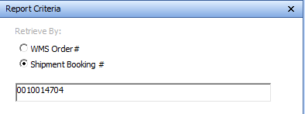

New criteria to include in report:

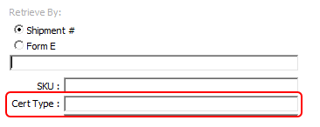

2.    Add an “Item Description” Column in the report. It is a requirement for us to have it in the report:

Current:

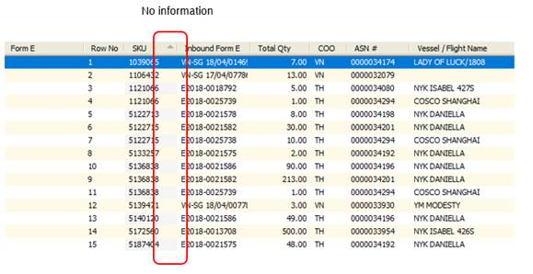

To add:

